Below Flowchart explains the User Stories development process. Please refer to documentation also for detail steps and checklists /gates. This is only for new User Stories in the release. For bug solving / customer tickets / analytic , separate workflows are followed.

Cross Functional Flow chart of User stories

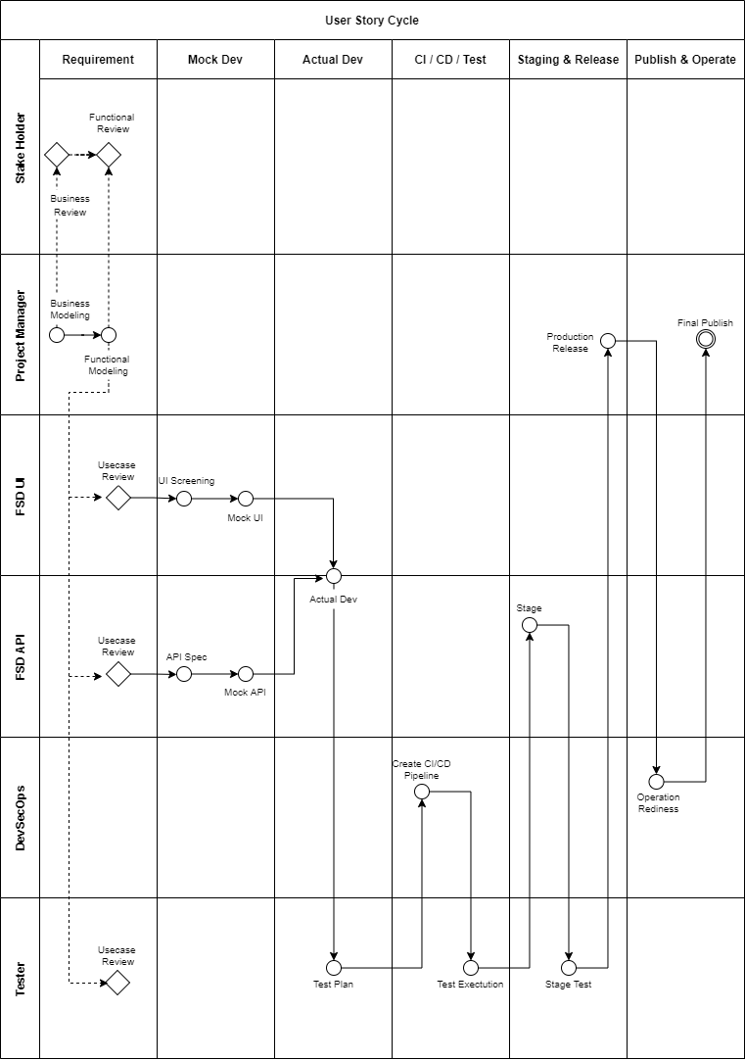

Below is the complete flowchart showing different stages of Development cycle. It is divided in 6 stages as below
- Requirement
- Mock Dev
- Actual Dev
- CI / CD / Test
- Staging and Test
- Publish and Operate

Requirement:

Requirement is the stage in which Project Manager will collect as much information from Project Owner and create a business model to carry out development process. Which will be periodically reviewed by project owner and once business and functional module is finalised project manager will proceed with Scrum planning.

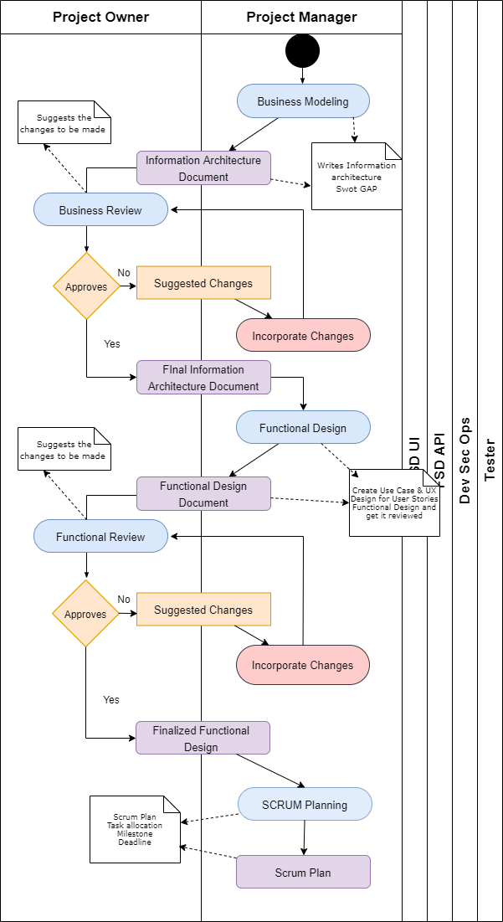

Mock Dev:

Project manager will review the functional design with UI and API team. Design team will provide API specs to API team. UI team will then create UI screens, Mock API then integrate Mock API with UI Screens. API team will create ERD, implement JDL and create Test data. Once PM reviews MocK integration API team will consolidate API with Test data

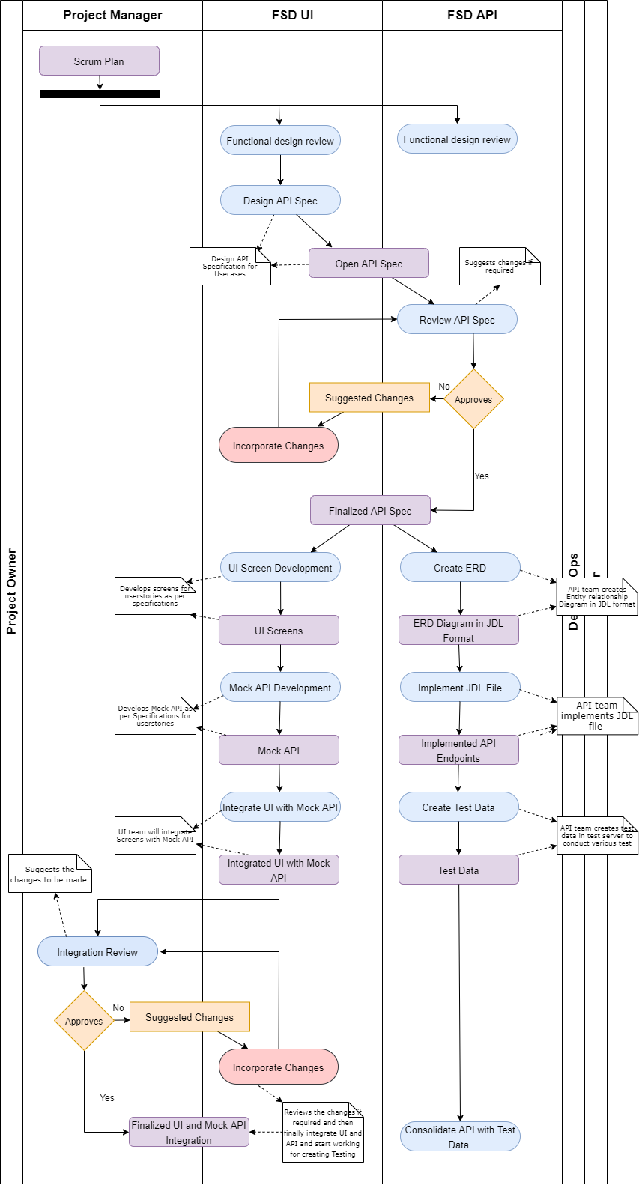

Actual Dev

Once API is consolidated with test data, UI team will integrate UI with Actual API and PM will review this integration and finalise UI Screen integration with API

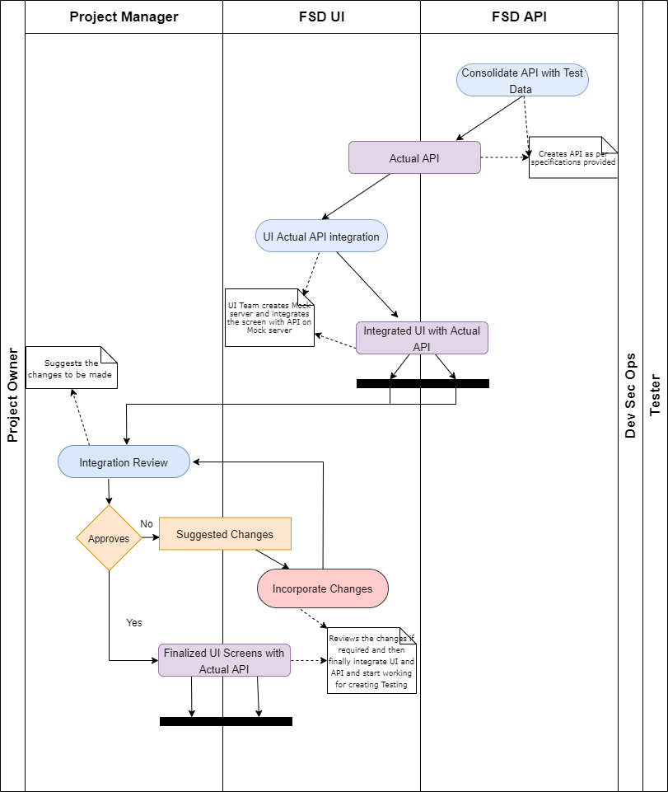

CI / CD / Test

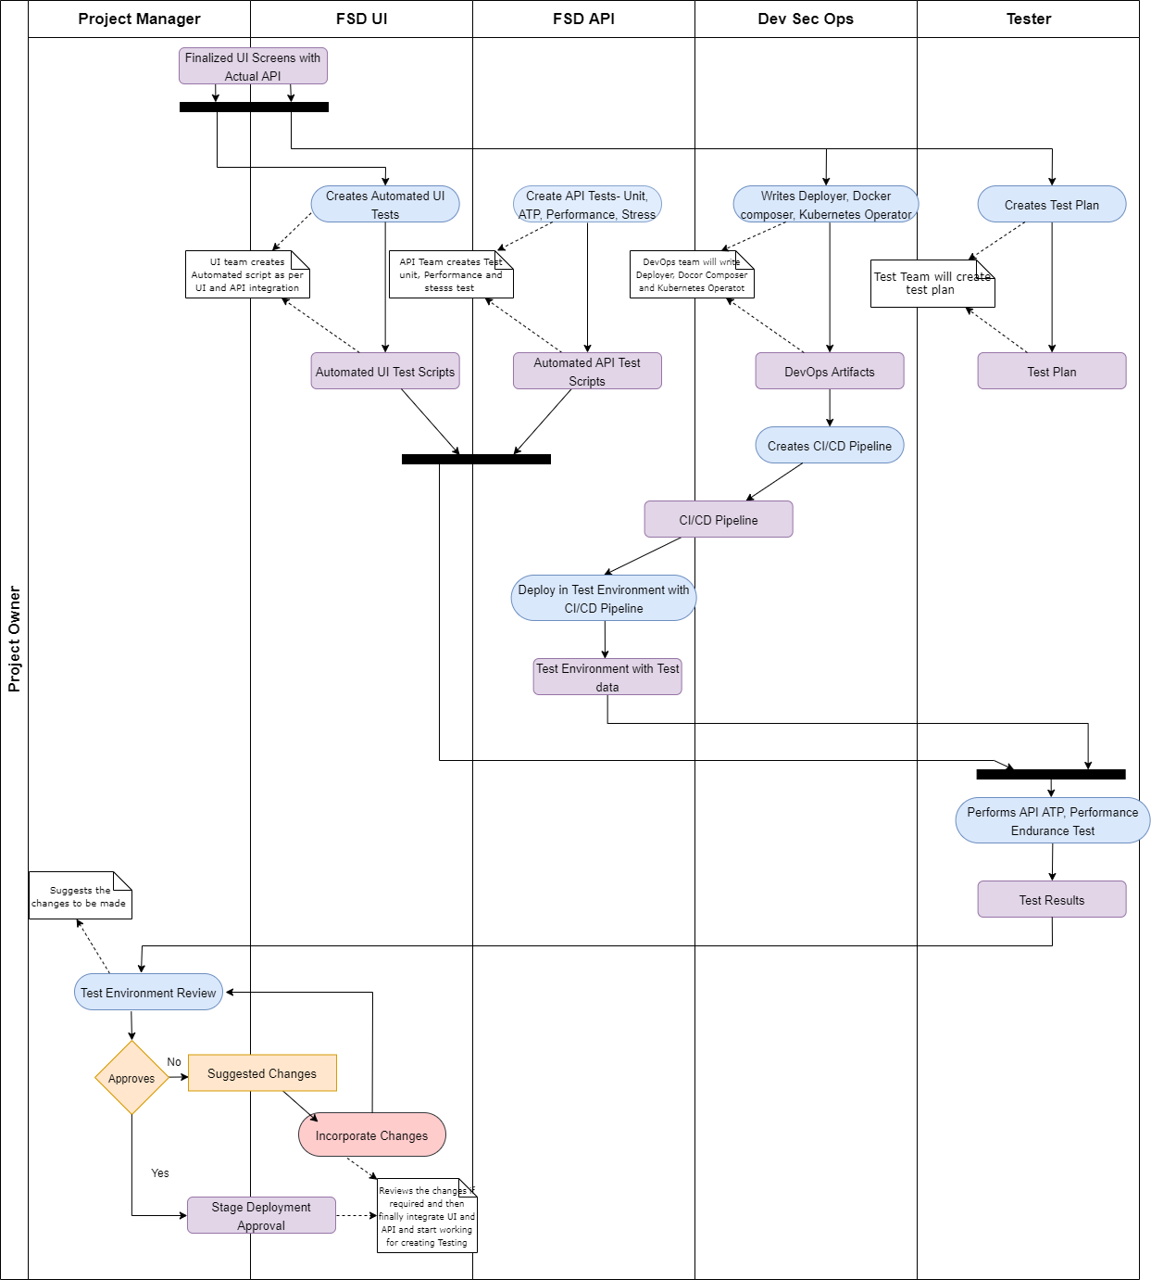

Staging and Test

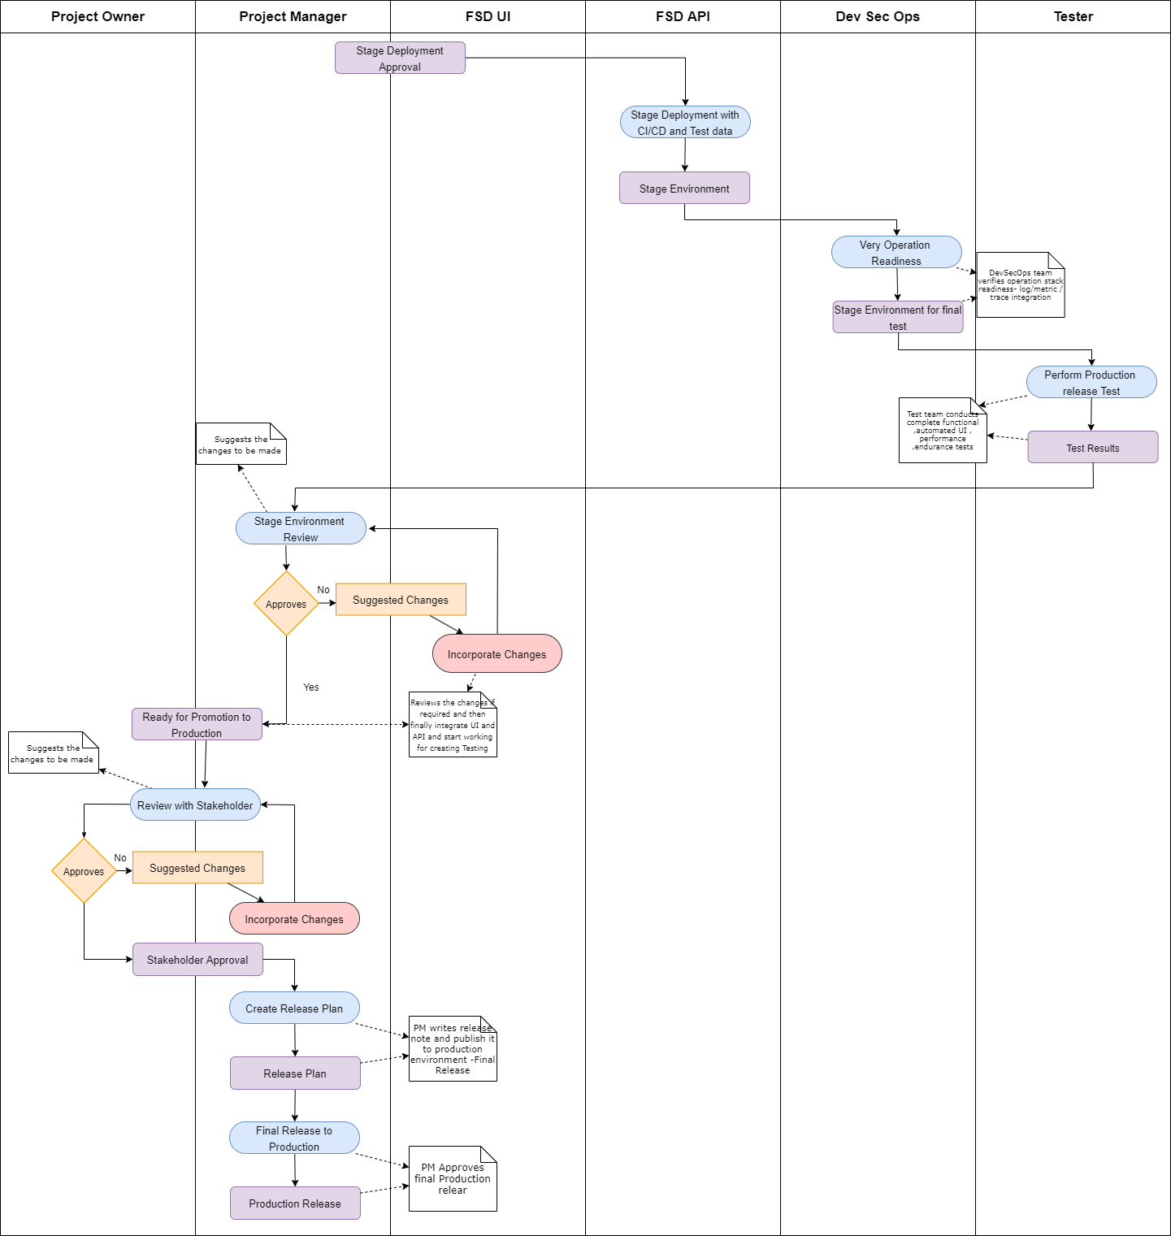

Publish and Operate

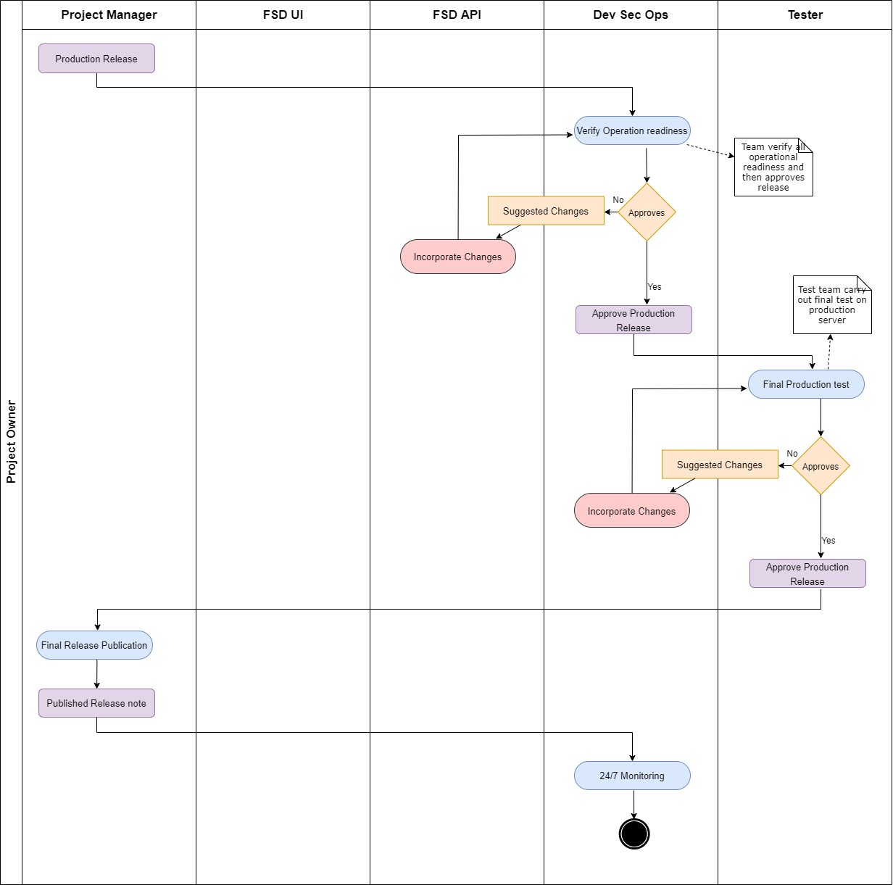

Here follows the details of tasks and checklists for every stages. The detail guidelines and trainings for every tasks is maintained separately in our netlify education portal.

Requirement

Tasks
-- Create Use Case Document
-- Create Screen Designs
--Do functional design review with tech team

Checklists --
-- Use Case Document is stitched in netlify site in Use Cases Matrix
-- Screen Design is stitched in netlify site in Use Cases Matrix
-- Functional Design Review meeting is done with Technical Team
-- Scrum Planning with Micro Level Task Allocation is done

Mock Dev

Tasks
-- Create OpenApi Specification
-- Create Postman Tests for OpenAPi specification
-- Create UI screens working with Mock API
-- Create Test Plans

Checklists --
-- Finalized API Specification is available in github
--API specification help documentation is available
-- API spec Review meeting is done with UI /API Team
-- UI code is available in GitHub that works with Mock API
-- The code has adequate build / test instructions to run mock server and review UI
-- Test Plans is available in Git and its stitched in netlify site in Use Cases Matrix

Actual Dev

Note: Let’s not proceed to actual dev unless business review is done

Tasks
-- Create Data Design Page in GitHub as MD file and is stitched in netlify site in Use Cases Matrix
-- Create API source Code in GitHub and is stitched in netlify site in Use Cases Matrix
-- Populate Test data or sample data file in GitHub
-- Create Junit5 Tests in GitHub
-- Create Cucumber BDD tests in GitHub
-- Create Gatling Performance/ Load Tests in GitHub
-- Do Code Review with Tech Lead
-- Do Actual UI-API integration
-- Do Branch Merge After review
-- Link API source Code in GitHub and netlify site in Use Cases Matrix

Checklists --
-- Data Design is available in GitHub and stitched properly
-- API source Code in GitHub and netlify site in Use Cases Matrix stitching is available
-- API Development followed the git flow of projects ( our gitops workflow like branching/ merging etc) to develop actual API
-- API sample data is available in GitHub
-- Adequate readme instruction is available in GitHub to run with sample data
-- API are tested against postman collection generated in mock stage
-- All unit / functional / performance tests are written and kept in GitHub
-- All functional /performance tests meet SLA's
-- All functional / Performance Tests
-- Actual API works with UI by simply changing Base URL
-- API follows 10 Points API security verification
-- API is properly instrumented for performance metrics / logs / traces
-- Perf Metrics / Logs / Trace destination is configurable

CI/CD/TEST

Tasks

-- CI/CD pipeline is created with common builders/ deployer's / testers that we have created - custom tekton building blocks.
-- Kubernetes Operator is created for the service
--Deploy in Test ENV via CI/CD pipeline
-- Do acceptance tests in test ENV
-- Upload Test results in S3 website and link with netlify website
-- Upload Test ENV URL in netlify site
-- Stage after review by lead

Checklists –

-- Test results are loaded in S3 website and linked with netlify website
-- Test ENV URL is accessible from netlify site
-- CI/CD pipeline is integrated with tests(Unit / functional ATP / performance )
-- CI/CD pipeline can deploy the service in test ENV with sample data
-- CI/CD pipeline has the post-deployment verification available
-- Adequate readme instruction is available in GitHub to run the CI/CD pipeline
-- Stage ENV URL is accessible from netlify site
-- Adequate readme instruction is available to run stage testing by PM

Stage/Release

Tasks
-- Stage tests and review by PM
-- PM Promote To prod
-- PM performs API security tests in prod
-- PM creates/updates release notes

Checklists --
-- Stage Tests results are loaded in S3 website and linked with netlify website
-- Prod ENV URL is accessible from netlify site
-- Prod ENV security Tests are accessible from netlify site
-- Updated Product release is available in GitHub and linked in netlify site

Publish/Operate

Tasks
-- Prod ENV are reviewed by DevOps team from security & operation readiness perspective
-- PM announce the release note to world

Checklist --
-- Prod ENV confirms API security guideline
-- Prod ENV rightly integrate with performance / trace / log manager
-- Final announcement email is circulated to customers with a link to release note by PM

